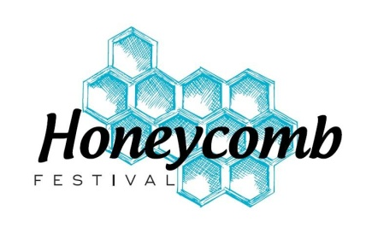
HONEYCOMB FESTIVAL PROGRAMME NOTES
Tuesday 7th, Wednesday 8th, Thursday 9th and Friday 10th April 2026
Please attach this form and a clearly labelled photo for each group onto the website www.honeycombfestival.co.uk by FRIDAY 6th FEBRUARY 2026.

If you have more than one group performing, please submit one form for each group.

* Please highlight the day you are performing: Tuesday Wednesday Thursday Friday

* If you have a performer who is also participating with another group on the same day, please provide their name and which group they belong to:

* Contact name, phone number and email of person completing form:

The details below will be the details that will appear in the programme.

Name of group

Name of piece

Group name (if different to performance group name above)

Choreographer

Performers

General details of your group (maximum 40 words)

Contact and name and details

