3a.
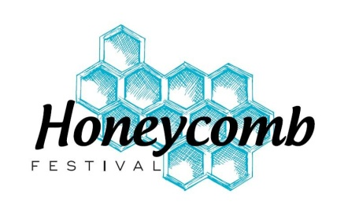
HONEYCOMB FESTIVAL
TECHNICAL REQUIREMENTS musical theatre/drama
MONDAY 14TH, TUESDAY 15THAPRIL 2025

PLEASE HIGHLIGHT WHICH DAY YOU ARE PERFORMING

Please attach this document to the form on the website www.honeycombfestival.co.uk by

FRIDAY 7TH FEBRUARY 2025

- The stage is apx 12sq.metres (or 6sq. metres with black tabs), has wings and a dance floor.
- You will enter stage left and exit stage right.
- Please take a bow at the end of your piece.
- There will only be 6 solo mics – no more are available.
- The ensemble will be amplified by directional mics at front of stage.
- All soloists need to be at the side of stage 15 mins before tech rehearsal time to get mic’d up.
- All groups need to provide a list of names of who is doing solos and allocate each soloist with a number: 6 only.
- Please also provide us with a copy of the script of your piece with the relevant mic number marked against the right part so that the tech team can turn on the right mic at the right time.
- Please make it clear on the script when the ensemble is singing or talking.
- If you are pre-recording music, this needs to be of a very high quality – if possible with music in mono on the left and vocals on the right so that the tech team are able to mix the two.
- Please record ALL vocals or none at all.
- Take care how you mix the tracks – the tech team are unable to work miracles with sound quality!

Contact name, phone number and email of person completing this form:

Judy Munday 07989 922609 judy@honeycombfestival.co.uk

HONEYCOMB FESTIVAL MUSICAL THEATRE/DRAMA TECHNICAL REQUIREMENTS

Name of piece

Group name

Length of piece

Lighting etc requirements – please be as specific as possible
The following is available: (there are no sidelights)
- basic red, blue, amber and white washes - white/black background
- star cloth - chasers

Other requirements, eg props, chairs etc (these details are very important for theatre health and safety regulations). Please be as specific as possible.

Please give us some idea of costumes the performers will be wearing:

List of soloists with allocated number

Music: (please ensure that if you are using a mix of music, then all details of all artists are required)
WAV files are preferred if possible.

Attach a copy of script of your piece.

I confirm I am emailing my music as a WAV attachment to Deborah at deborah@honeycombfestival.co.uk

