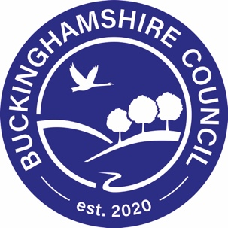
BUCKINGHAMSHIRE COUNCIL
Children’s Services

CHILDREN AND YOUNG PERSONS ACT 1933 s.25/1963, S.37
The Children (Performances and Activities) (England) Regulations 2014

LETTER OF ASSURANCE

Name of Organisation:……………………………………………………………….……….………………….…………….….…………….

Name of employee: ………………………………………………………………………...….………………………………..…………………

DBS Certificate Number
Date of DBS Certificate
Level of DBS Certificate  (please tick) | Basic:  Standard:  Enhanced:
Any other checks  (pleased tick if appropriate)) | DBS Children’s Barred List date:  DBS Adults’ Barred List date:  Prohibition Order Check (for teachers only) date:  Childcare (Disqualifications) Regulations 2009 (where working with children under age 8) date:
* I confirm that this organisation complies fully with the DBS Code of Practice @ www.dbs.gov.uk
* I confirm that all appropriate vetting procedures (including appropriate ID checks and confirmation of address) have been carried out and that the above named employee has a current DBS Enhanced Certificate (including a Barred List Check) if required
* I agree to advise Buckinghamshire Council, Child Employment Officer, of any concerns we may have about the above named employee
* I confirm that the above named employee will adhere to Buckinghamshire Council’s safeguarding policies
I declare that the above Disclosure / Prohibition Order / Childcare (Disqualification) Regulations 2009 Checks – as appropriate - are clear and that no additional information about the above individual has been subsequently received. I shall contact the Council immediately if there is any information on any future relevant DBS Certificates / Prohibition Order Checks / Childcare Disqualifications Checks (as appropriate) received in respect of the above employee.

Signed:………………………………………………………………………………………………………………Date:……………………………………

Position in Company: ……………………………………………………………………………………………………………………...

Name (Please print): …………………………………………………………………………………………………………………………

Buckinghamshire Council reserves the right to terminate the existing contract if the above organisation fails to have any of the above procedures in place. Buckinghamshire Council is committed to safeguarding and promoting the welfare of children and young people and expects all staff and volunteers to share this commitment.

